

How to leverage AWS Lex to create an automated COVID assessment BOT.

**AWS Services used**

.

* Amazon Lex
* Amazon DynamoDB
* Amazon CloudFront
* AWS Amplify
* AWS Lambda
* AWS Cloud9
* AWS Code Commit
* AWS s3
* Amazon CloudFront
* Amazon AppSync

**About** **Covid Bot Solutions**

This case study is regarding the creation of a COVID Assessment tool consisting of a genie which interacts as a chatbot for voice and text based interactions. Covid Assessment bot is a tool that leverages multiple features of AI such a voice,

Natural language processing and decision making to provide a solution that can scale to serve multiple people and help them.

.

**Challenge**

* The challenge was to create a chatbot which interacts with the user and suggested whether he/she is prone to COVID-19 based on a set of related questions. The bot responds to user’s voice and text replies by real time responsesvxcvxcvxcvxcvxcvxvxcvxcvxcvxcvxcvxcvxcvxcvxcvxcvxcvvvvvvvvvvvvvvvvvvvvvvvvv
* React Js

**Other Services used**

**xcvxcvxcvxcv**

**x**

* User interaction with the Gennie.
* Chatbot gives voice and text-based responses.
* Real Time Responses based on Conversation

**Proposed Solution**

* Conversational chatbot which interacts with the user via written or spoken medium to identify the risk of COVID
* Seamless experience with real time responses
* Used tools and technologies like conversational AI which allows healthcare organizations to provide care at critical points along with maintaining the aesthetic flow of the virtual conversation

**Solution Outcome**

**BOT Architecture – AWS Cloud**

Architecture Diagram

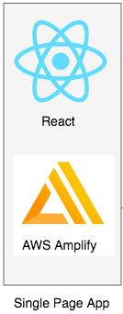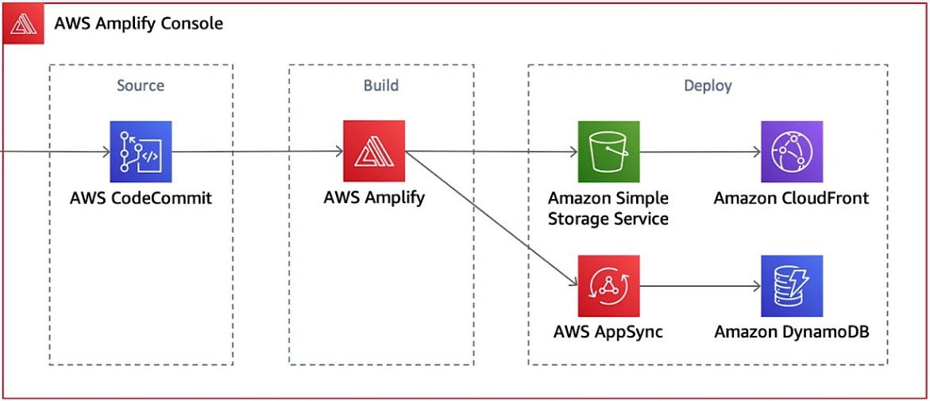

Visit the following link to access the bot**:**

<https://master.dcjrsebf77vbs.amplifyapp.com/Chat>

1. Homepage of Bot

Homepage of covid bot


1. Bot Interaction

About the Partner

MothersonSumi INfotech & Designs Ltd.

MothersonSumi INfotech & Designs Limited (MIND), a SEI CMMI Level 5 IT services company and the IT back bone of Motherson group. MIND is a trusted technology partner to over 200 clients globally. Our value proposition is in our strength in specific Industry segments and years of experience in the areas of intelligent warehousing, Supply chain enablement, software application development, smart ERP customization, infra managed services, cloud, IoT & Analytics. MIND is serving customers in 41+ countries with a strong team of 1500+ professionals.